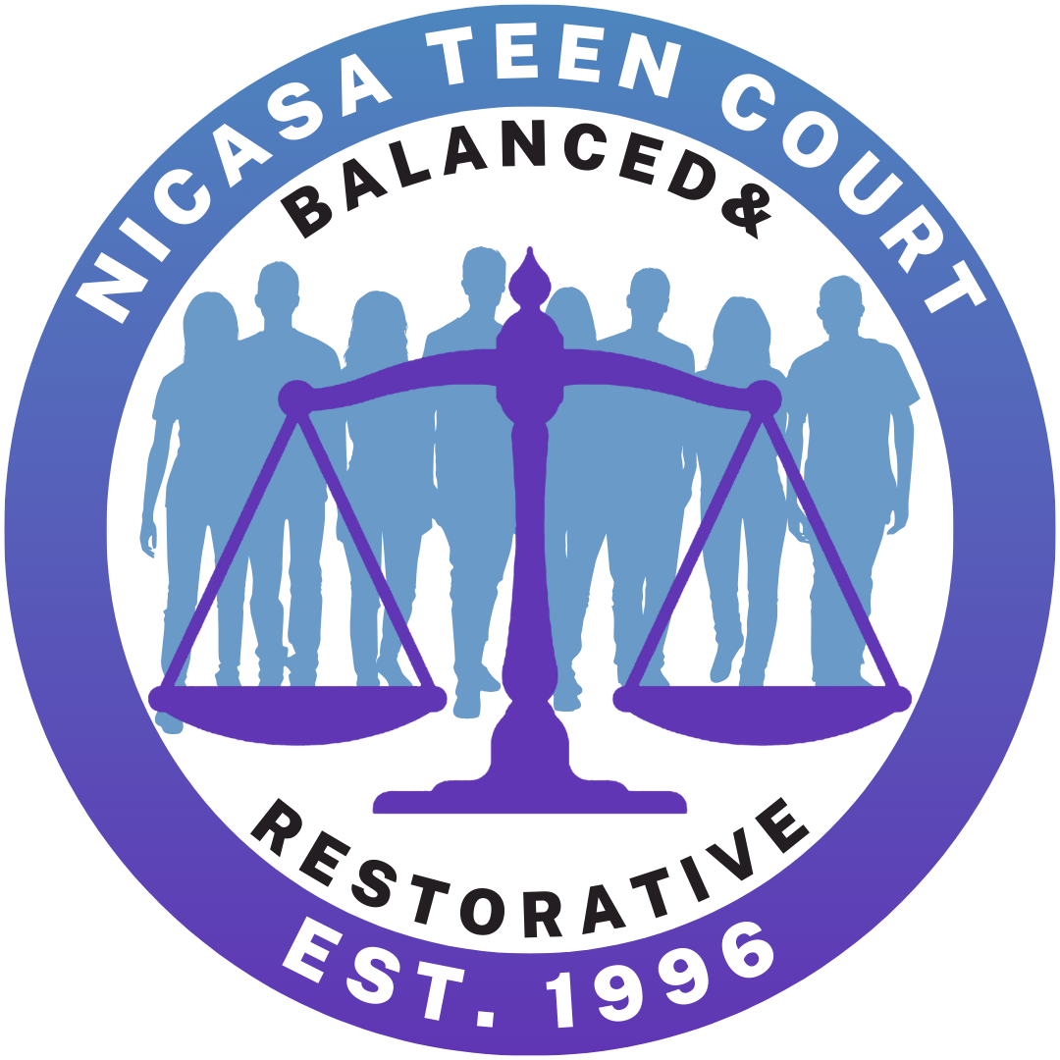
NICASA TEEN COURT
Application for Juror/Attorney
$12 Teen Court shirt fee payable once accepted

DATE:
NAME:
ADDRESS:
CITY: |  |  |  |  |  |  |  |  |  |  |  |  | STATE: |  |  |  | ZIP:
CELL: |  |  |  |  |  |  |  |  |  |  | EMAIL:
DATE OF BIRTH:
SCHOOL: |  |  |  |  |  |  |  |  |  |  |  |  |  |  | H.S. GRADUATION YR
LIST CURRENT EXTRACURRICULARS/JOB:
SIGNATURE:
PARENTAL CONSENT:
(Signature)

Please review the attached schedule and select up to three court locations you can attend. You may be assigned a court based on location needs.
Home Court Choice 1: ________________ Home Court Choice 2: ________________
Home Court Choice 3: _______________

NOTE: The Teen Court program operates under the jurisdiction of the 19th Judicial Circuit Court, requires strict confidentiality and calls for the protection of privacy of the defendants, jury members and teen attorneys involved in the program. In accordance with this, we ask that you do not divulge the identity of defendants, their family members or any information disclosed to you while you are a member of the Teen Court Program. By signing this application, you agree to abide by the rules of confidentiality if you are accepted as a Teen Court juror. You also agree to be photographed for Teen Court newsletters and other Teen Court and Nicasa related content.
Please return this application & statement of interest to:
Paola Martinez
c/o Nicasa Behavioral Health Services
31979 N Fish Lake Road
Round Lake, IL 60073
pmartinez@nicasa.org
847-201-8543 (phone 1)
847-924-2662 (phone 2)
STATEMENT OF INTEREST

What do you think will be your biggest contribution to Teen Court?

Why do you think it’s important to honor your commitment to teen court?

NICASA TEEN COURT APPLICATION

Since 1996 Nicasa, in conjunction with Lake County Police Departments and the Lake County Sheriff’s Department, has instituted a Teen Court Program and is currently recruiting new volunteers for the roles of jurors and attorneys.
The primary goal of Teen Court is to attempt to instill accountability and responsibility in juvenile offenders’ ages 10 - 17 years of age. The juveniles who appear before their peers in Teen Court are referred by the juvenile officers of the police department, as part of the station adjustment process, and as an alternative to Juvenile/Branch Court. The juvenile participant and their parents will already have been interviewed by the juvenile officer. Several factors will determine if the juvenile participant is eligible to appear in Teen Court. The most important factor will be that the juvenile admits their guilt of criminal charges.
The juvenile participant will appear in Teen Court with their parents. A teen attorney will explain the facts of the case to the teen jury. The teen jurors will then have a chance to question the juvenile participant about the incident. After deliberating, the teen jury will hand down a constructive sentence to the participant. In keeping with the goal of instilling accountability and responsibility in the juvenile participant, the sentence handed down by the jury will always consist of community service and participation in educational life skills program.
The participant will be given a return date; and on that date, verification of completion of the sentence must be presented to the jury. If a juror or attorney knows a participant, the person will be excused from the case. Care will be taken to ensure confidentiality. Community service assignments will help participants connect to the community in a positive way.
The Teen Court Program is currently seeking teens ages 14 to 18, who live in or attend high school in Lake County, IL, to serve as jurors and attorneys. Volunteers must maintain a C average in all classes, have parental consent and remain drug and alcohol free. Youth volunteering for 2 or more years are eligible to receive a Teen Court Scholarship to help with their college tuition.
Prospective jurors and attorneys will be required to attend an orientation with their parent/guardian. The completed application, statement of interest and participation in the training will determine who will be chosen to serve during the year. Notification of acceptance will be made by email following the Teen Court juror training.
If you are interested, please fill out the attached application and return it to Paola Martinez using the information below.

Nicasa Behavioral Health Services * 31979 Fish Lake Road * Round Lake, IL 60073
847-201-8543 (phone 1) * 847-924-2662 (phone 2) * pmartinez@nicasa.org

Teen Court Dates
2026/2027

 | WESTERN LAKE  COUNTY COURT |  |  | CENTRAL LAKE COUNTY COURT
RLB #1 |  | RLB #2 | FL | Gurnee
1st Wed |  | 2nd Wed | 3rd Wed | 2nd Thu
07/01/26 |  | 07/08/26 | 07/15/26 | 07/09/26
08/05/26 |  | 08/12/26 | 08/19/26 | 08/13/26
09/02/26 |  | 09/09/26 | 09/16/26 | 09/10/26
10/07/26 |  | 10/14/26 | 10/21/26 | 10/15/26
11/04/26 |  | 11/11/26 | 11/18/26 | 11/12/26
12/2/26 |  | 12/09/26 | 12/16/26 | 12/10/26
01/06/27 |  | 01/13/27 | 01/20/27 | 01/14/27
02/03/27 |  | 02/10/27 | 02/17/27 | 02/11/27
03/03/27 |  | 03/10/27 | 03/17/27 | 03/11/27
04/07/27 |  | 04/14/27 | 04/21/27 | 04/15/27
05/05/27 |  | 05/12/27 | 05/19/27 | 05/13/27
06/02/27 |  | 06/09/27 | 06/16/27 | 06/10/27
07/07/27 |  | 07/14/27 | 07/21/27 | 07/15/27
08/04/27 |  | 08/11/27 | 08/18/27 | 08/12/27
**Teen Court is all year round; you will be provided with an updated calendar at the end of the fiscal year.**
Western Lake County Court - Referrals from Round Lake, Round Lake Beach, Round Lake Heights, Round Lake Park, Fox Lake, Wauconda Police Departments and Lake County Sheriff
Central Lake County Court - Referrals from Gurnee, Waukegan, Zion, Winthrop Harbor Police Departments and Lake County Sheriff
Eastern Lake County Court - Referrals from Waukegan, North Chicago, Gurnee, Zion, Winthrop Harbor Police Departments and Lake County Sheriff

Court begins promptly at 7:00 pm. All jurors are expected to arrive by 6:00 pm to review and prepare for cases.
Court Addresses
Round Lake Beach | Fox Lake
Round Lake Beach Village Hall | Fox Lake Village Hall
1937 Municipal Way | 66 Thillen Drive
Round Lake Beach, IL 60073 | Fox Lake, IL 60020
Gurnee
Gurnee Village Hall
325 O’Plaine Road
Gurnee, IL 60031

In the event of inclement weather, please contact Paola Martinez at 847-924-2662 or pmartinez@nicasa.org to verify that court has not been cancelled prior to coming to court.

