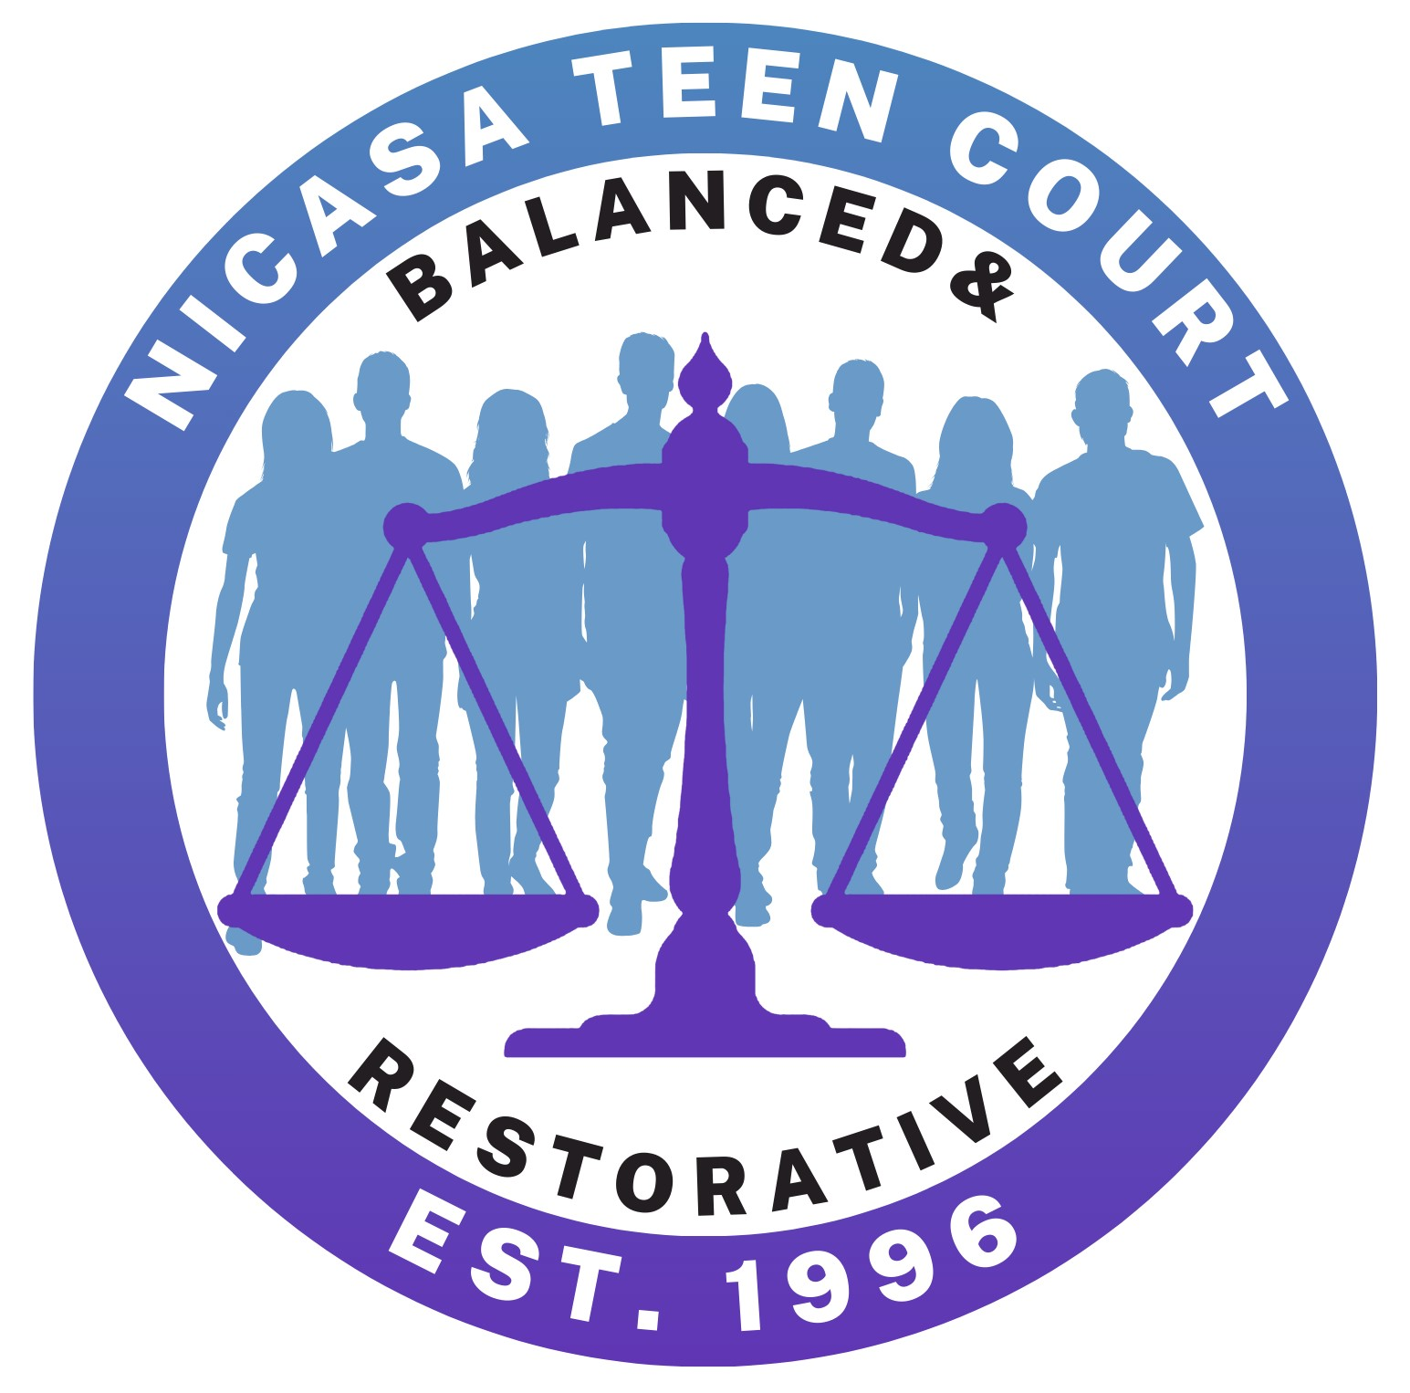
NICASA TEEN COURT
Application for Juror/Attorney 2024
$10 Teen Court polo shirt fee payable once accepted

DATE:
NAME:
ADDRESS:
CITY: |  |  |  |  |  |  |  |  |  |  |  |  | STATE: |  |  |  | ZIP:
CELL: |  |  |  |  |  |  |  |  |  |  | EMAIL:
DATE OF BIRTH:
SCHOOL: |  |  |  |  |  |  |  |  |  |  |  |  |  |  | GRADUATION YR
LIST CURRENT EXTRACURRICULARS/JOB:
SIGNATURE:
PARENTAL CONSENT:
(Signature)

Please review the attached schedule and select up to three courts you can attend. You may be assigned a court based on location needs.
Home Court Choice 1: ________________ Home Court Choice 2: ________________
Home Court Choice 3: ________________

NOTE: The Teen Court program operates under the jurisdiction of the 19th Judicial Circuit Court, requires strict confidentiality and calls for the protection of privacy of the defendants, jury members and teen attorneys involved in the program. In accordance with this, we ask that you do not divulge the identity of defendants, their family members or any information disclosed to you while you are a member of the Teen Court Program. By signing this application, you agree to abide by the rules of confidentiality if you are accepted as a Teen Court juror.
Please return this application & statement of interest to:
Viviana Arzate
c/o Nicasa Behavioral Health Services
31979 N Fish Lake Road
Round Lake, IL 60073
varzate@nicasa.org
847-201-8543 (phone)
847-546-6760 (fax)

STATEMENT OF INTEREST

What do you think will be your biggest contribution to Teen Court?

Why do you think it’s important to honor your commitment to teen court?

NICASA TEEN COURT APPLICATION

Since 1996 Nicasa, in conjunction with Lake County Police Departments and the Lake County Sheriff’s Department, has instituted a Teen Court Program and is currently recruiting new volunteers for the roles of jurors and attorneys.
The primary goal of Teen Court is to attempt to instill accountability and responsibility in juvenile offenders’ ages 10 - 17 years of age. The juveniles who appear before their peers in Teen Court are referred by the juvenile officers of the police department, as part of the station adjustment process, and as an alternative to Juvenile/Branch Court. The juvenile offender and his/her parents will already have been interviewed by the juvenile officer. Several factors will determine if the juvenile offender is eligible to appear in Teen Court. The most important factor will be that the juvenile admits his/her guilt of the criminal charges.
The juvenile offender will appear in Teen Court with his/her parents. A teen attorney will explain the facts of the case to the teen jury. The teen jurors will then have a chance to question the juvenile offender about the incident. After deliberating, the teen jury will hand down a constructive sentence to the offender. In keeping with the goal of instilling accountability and responsibility in the juvenile offender, the sentence handed down by the jury will always consist of community service and participation in educational life skills program.
The offender will be given a return date; and on that date, verification of completion of the sentence must be presented to the jury. If a juror or attorney knows an offender, the person will be excused from the case. Care will be taken to ensure confidentiality. Community service assignments will help offenders connect to the community in a positive way.
The Teen Court Program is currently seeking teens ages 14 to 18, who live in or attend high school in Lake County, IL, to serve as jurors and attorneys. Volunteers must maintain a C average in all classes, have parent consent and remain drug and alcohol free. Youth volunteering for 2 or more years are eligible to receive a Teen Court Scholarship to help with their college tuition.
Prospective jurors and attorneys will be required to attend an orientation with their parent/guardian. The completed application, statement of interest and participation in the training will determine who will be chosen to serve during the year. Notification of acceptance will be made by email following the Teen Court juror training.
If you are interested, please fill out the attached application and return it to Viviana Arzate using the information below.

Nicasa Behavioral Health Services * 31979 Fish Lake Road * Round Lake, IL 60073
847-201-8543 (phone) * 847-546-6760 (fax) * varzate@nicasa.org
Teen Court Dates
2024/2025

 | WESTERN LAKE  COUNTY COURT |  |  | CENTRAL LAKE COUNTY COURT
RLB #1 |  | RLB #2 | FL | Gurnee
1st Wed |  | 2nd Wed | 3rd Wed | 2nd Thu
06/05/24 |  | 06/12/24 | NO COURT | 06/13/24
NO COURT |  | 07/10/24 | 07/17/24 | 07/11/24
08/07/24 |  | 08/14/24 | 08/21/24 | 08/08/24
09/04/24 |  | 09/11/24 | 09/18/24 | 09/12/24
10/02/24 |  | 10/09/24 | 10/16/24 | 10/10/24
11/06/24 |  | 11/13/24 | 11/20/24 | 11/14/24
12/04/24 |  | 12/11/24 | 12/18/24 | 12/12/24
NO COURT |  | 01/08/25 | 01/15/25 | 01/09/25
02/05/25 |  | 02/12/25 | 02/19/25 | 02/13/25
03/05/25 |  | 03/12/25 | 03/19/25 | 03/13/25
04/02/25 |  | 04/09/25 | 04/16/25 | 04/10/25
05/07/25 |  | 05/14/25 | 05/21/25 | 05/08/25
06/04/25 |  | 06/11/25 | 06/18/25 | 06/12/25
07/02/25 |  | 07/09/25 | 07/16/25 | 07/10/25
08/06/25 |  | 08/13/25 | 08/20/25 | 08/14/25

Western Lake County Court - Referrals from Round Lake, Round Lake Beach, Round Lake Heights, Round Lake Park, Fox Lake, Wauconda Police Departments and Lake County Sheriff
Central Lake County Court - Referrals from Gurnee, Waukegan, Zion, Winthrop Harbor Police Departments and Lake County Sheriff
Eastern Lake County Court - Referrals from Waukegan, North Chicago, Gurnee, Zion, Winthrop Harbor Police Departments and Lake County Sheriff

Court begins promptly at 7:00 pm. All jurors are expected to arrive by 6:00 pm to review and prepare for cases.
Court Addresses

Round Lake Beach | Fox Lake
Round Lake Beach Village Hall | Fox Lake Village Hall
1937 Municipal Way | 66 Thillen Drive
Round Lake Beach, IL 60073 | Fox Lake, IL 60020
Gurnee
Gurnee Village Hall
325 O’Plaine Road
Gurnee, IL 60031

In the event of inclement weather, please contact Viviana Arzate (847-201-8543 or varzate@nicasa.org) to verify that court has not been cancelled prior to coming to court.

